Annual Holiday Tree Lighting
Saturday, December 1, 2018
6:00pm at Lake Como Borough Hall
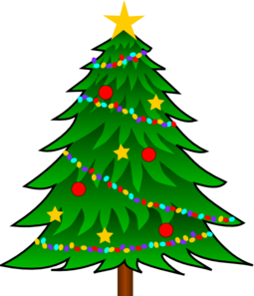

The festivities begin in the Lake Como Meeting Room with crafts and snacks and a special visit from Santa!

