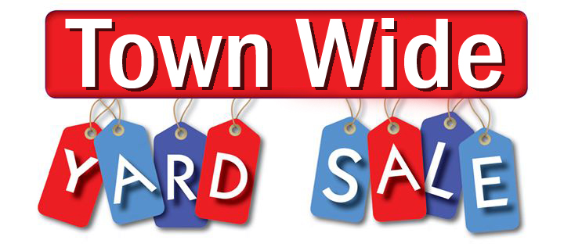

2021 Yard Sale Participants
410 18th Avenue
504 18th Avenue
709 18th Avenue
724 20th Avenue
701 21st Avenue
1810 Laurel Terrace
1804 Pine Terrace

